

# **Department of Basic Science and Humanities**

# **Institute of Engineering & Management, Kolkata**

**“Bank Management System”**

**Submitted by:**

**Name: Subhomoy Ganguly**

**Enrolment Number: 12022002002200**

**Stream: Computer Science & Engineering**

**Section: A**

**Class Roll no.: 91**

**Subject: Programming for Problem Solving**

**Subject Code: ESC-103(Pr)**

**Under the supervision of-**

**Prof. Swarnendu Ghosh**

**Academic Year: 2022-2026**

**(**PROJECT REPORT SUBMITTED IN FULFILMENT OF THE REQUIREMENTS FOR THE SECOND SEMESTER)



**CERTIFICATE OF RECOMMENDATION**

We hereby recommend that the project prepared under our supervision by **Devsatyam Ray**, entitled “**Bank Management System**” be accepted in fulfilment of the requirements for the degree of fulfilment of the second semester.

___________________ ____________________

Head of the Department Project Supervisor

1. **Introduction:**

This project is assigned to me for developing a Bank Management System with the help of basic C programming language. The basic aim of the project is to create a bank management system where we can create account details, withdraw or deposit money and thereby with the help of c programming, it creates a .exe file which can run a command line interface to work with the bank management system.

1. **Variable Description:**

* Int customer_number:

To store the specific customer number in integer form.

* Char name:

To store user name in string format.

* Float balance:

To store total balance available in float format.

* Int customer_count:

To store the total number of customers in integer format.

* Int account_number:

To store the customer’s account number in integer format.

* Float amount:

To store the customer’s amount in float format.

* Int choice:

To store the choice number at the menu page.

1. **Function Description:**

* **Create_account():**

To create a new customer’s account.

* **Deposit():**

To deposit money into customer’s account.

* **Withdraw():**

To withdraw money from customer’s account.

* **View_Balance():**

To view balance of the customer’s account.

* **Exit(0):**

To quit the bank management system program.

1. **Programs:**

**#include<stdio.h>**

**#include<stdlib.h>**

**#include<string.h>**

**// Define customer structure**

**struct customer {**

**char name[50];**

**int account_number;**

**float balance;**

**};**

**// Declare global variables**

**struct customer bank[100];**

**int customer_count = 0;**

**// Function to create a new customer account**

**void create_account() {**

**printf("(Enter first name only)");**

**printf("Enter customer name: ");**

**scanf("%s", bank[customer_count].name);**

**printf("Enter account number: ");**

**scanf("%d", &bank[customer_count].account_number);**

**printf("Enter initial balance: ");**

**scanf("%f", &bank[customer_count].balance);**

**printf("Account created successfully!\n");**

**customer_count++;**

**}**

**// Function to deposit money into a customer account**

**void deposit() {**

**int account_number;**

**float amount;**

**printf("Enter account number: ");**

**scanf("%d", &account_number);**

**for(int i = 0; i < customer_count; i++) {**

**if(bank[i].account_number == account_number) {**

**printf("Enter amount to deposit: ");**

**scanf("%f", &amount);**

**bank[i].balance += amount;**

**printf("Deposit successful!\n");**

**return;**

**}**

**}**

**printf("Account not found.\n");**

**}**

**// Function to withdraw money from a customer account**

**void withdraw() {**

**int account_number;**

**float amount;**

**printf("Enter account number: ");**

**scanf("%d", &account_number);**

**for(int i = 0; i < customer_count; i++) {**

**if(bank[i].account_number == account_number) {**

**printf("Enter amount to withdraw: ");**

**scanf("%f", &amount);**

**if(amount > bank[i].balance) {**

**printf("Insufficient funds.\n");**

**return;**

**}**

**bank[i].balance -= amount;**

**printf("Withdrawal successful!\n");**

**return;**

**}**

**}**

**printf("Account not found.\n");**

**}**

**// Function to view balance for a customer account**

**void view_balance() {**

**int account_number;**

**printf("Enter account number: ");**

**scanf("%d", &account_number);**

**for(int i = 0; i < customer_count; i++) {**

**if(bank[i].account_number == account_number) {**

**printf("Account balance for %s: $%.2f\n", bank[i].name, bank[i].balance);**

**return;**

**}**

**}**

**printf("Account not found.\n");**

**}**

**// Main function**

**int main() {**

**int choice;**

**while(1) {**

**printf("******* Bank Management System ********\n");**

**printf("1. Create account\n");**

**printf("2. Deposit\n");**

**printf("3. Withdraw\n");**

**printf("4. View balance\n");**

**printf("5. Exit\n");**

**printf("Enter choice: ");**

**scanf("%d", &choice);**

**switch(choice) {**

**case 1: create_account(); break;**

**case 2: deposit(); break;**

**case 3: withdraw(); break;**

**case 4: view_balance(); break;**

**case 5: exit(0);**

**default: printf("Invalid choice.\n");**

**}**

**}**

**return 0;**

**}**

1. **Output:**

**Sample outputs(screenshots) to demonstrate the functionality of the program.**

1. **Menu Screen: Here you can choose the various option provided by the program.**

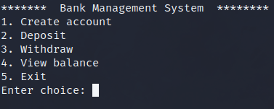

1. **Creating an account: If you want to create an account press 1.**

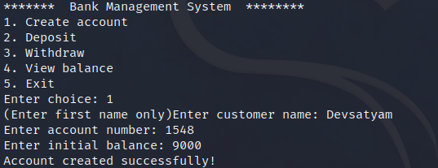

1. **Deposit Money: To deposit money press 2, it will verify your account number you have registered before and then enter your deposit amount. You can view the balance after that by pressing 4.**

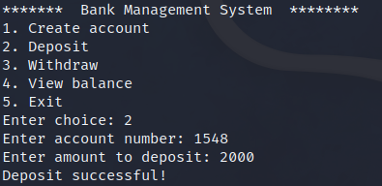

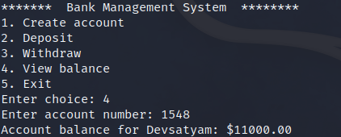

1. **Withdraw Money: To withdraw money press 3, it will verify your account number you have registered before and then enter your withdrawal amount.**

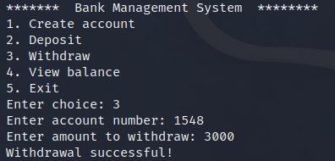

1. **View Balance: To view the remaining balance you need to press 4, then verify your account number.**

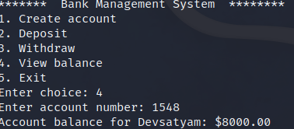

1. **Exit: To exit the program you can use *ctrl + c* or press 5 on the menu page. Remember once you exit the program all previous data will be gone.**

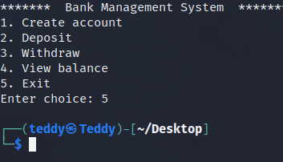

**Conclusion:**

**It is a Bank Management System made with pure C language. After running the executable file it’ll open a command line interface where the one can work with a bank management system.** Bank management system is a virtualization of transactions in banking system. The banking system are used manual working but when we used online banking system it is totally virtualization process which avoid manual process and converts it in automatic process.